 | MINISTRY OF EDUCATION AND TRAINING  FPT UNIVERSITY

Capstone Project Documents
TOLL MANAGEMENT
Unstopable
Group Members
  Name | Student ID
  Nguyễn Anh Nhật Linh | 00499
  Nguyễn Duy Vũ | 00521
  Trần Hải Đăng | 00357
  Nguyễn Xuân Hiếu | 00380
  Tô Văn Quân | 00425
Supervisor | Nguyễn Văn Sang
Ext Supervisor | Huỳnh Anh Dũng, Nguyễn Tất Trung
Capstone Project code | Toll Management v1

Hanoi, May 2011

Record of Changes
Date | Change Item | Description | By | Version
18/5/2011 | All | Create the document | LinhNan | 1.0
24/5/2011 | All | Update | QuanTV | 1.1

Table 1-1: References

TABLE OF CONTENTS
TABLE OF CONTENTS 3
1 Software project management plan 4
1.1 Problem definition 4
1.1.1 Definition and acronyms 4
1.1.2 Name of this CapStone Project 4
1.1.3 Problem Abstract 4
1.1.4 Project overview 5
1.2 Project organization 5
1.2.1 Software Process Model 5
1.2.2 Organizational Structure 6
1.3 Project Schedule 7
1.3.1 Detailed Schedule 7
1.3.2 Project final deliverables 10
1.4 Tools and Infrastrure 10
1.4.1 Development environment 10
1.4.2 Project Management Tools 11
1.5 Risk Management Plan 12
2 Coding Convention 15
2.1 Naming conventions 15
2.2 Coding styles 19
2.3 Comments 23
3 References 24

Software project management plan

Problem definition

Definition and acronyms
Acronyms | Definition | Note
TOM | Toll management | Name of project
DB | Database
ANPR | Automatic Number Plate Recognition
OS | Operation system | Operation system
PC | Personal computer
RUP | Rational Unified Process | Process model

Table 1-2: Definition and acronyms

Name of this CapStone Project
The Capstone project name is Toll Management. It’s a total solution for toll collection that we are ambitious for applying in Viet Nam.

Problem Abstract
In the Toll management project, the group with five members target to develop a system for managing all steps of a toll collection activity. Almost toll collection stations in Viet Nam using traditional method for toll collection activity: using human’s activity like seeing, checking, handling…. Or some stations applied automatic system for recognizing number plate, but toll collection activity is still depended on human so much, synchronizing timely data about number plate info between local station and Vietnam Register System is impossible. A total solution integrating all activities that overcomes all those disadvantages and is possible to deploy for all toll collection stations in Viet Nam in near future is the propose of this project.
Once completed, the product will archive the following characteristics:
- Recognizing number place of transports exactly, quickly for thoroughly traffic.
- Having a good initial database for managing toll collection: monthly, daily.
- Having various reports for manager review activities of each station.
- Ability to synchronize timely data between local database and Vietnam Register System’s database is the difference.
- Contributing to Viet Nam’s traffic development in general and toll collection in particular.

Project overview

No | Title | Vertion | Note
1 | Report #1 – Project Description | 1.0 | Description of project

Table 1-3: References

Project organization

Software Process Model
The process model used for developing this project is RUP, a type of Iterative Development Model. [1]
Process Model
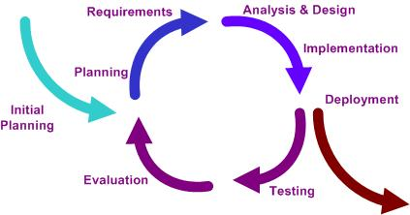
Figure 1-1: Process model

Project lifecyle
TOM project is a development and complex project, project implementation time is rather short, and it has full of phases from business analysis to test. Besides the major project, there are pilot projects like preparation and adjustment steps to ensure maximum success for the major project. Project team proposed Project Lifecycle with the phases that are described above to ensure that the issues and the quality of project can be controlled with a best way. This proposal is obeyed with the standard software development Lifecycle.

Organizational Structure
Organisation Structure
The figure below describes organisation structure of the project team.
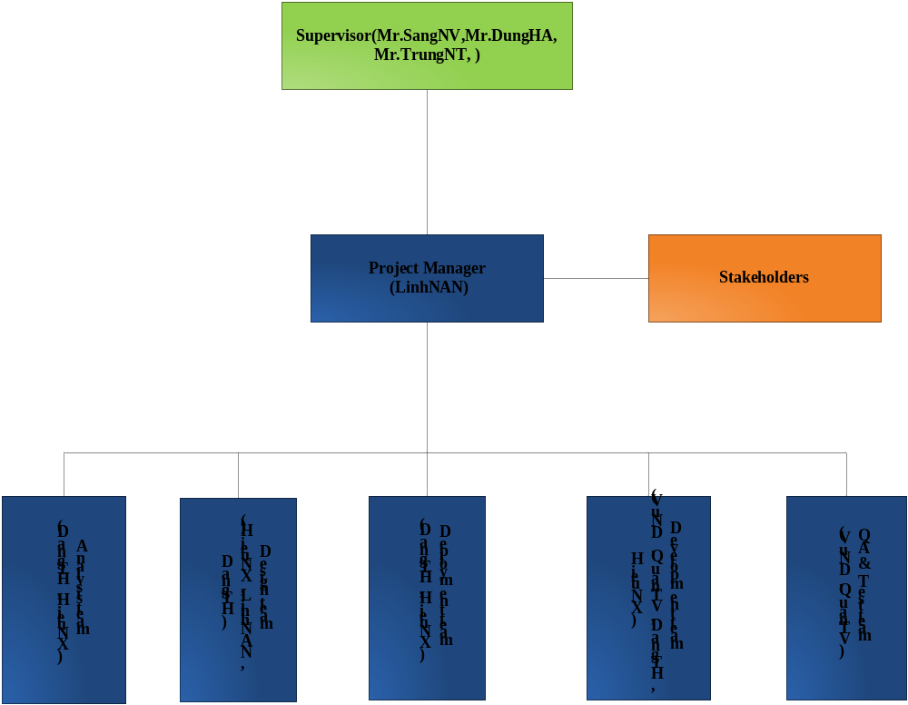
Figure 1-2: Organisation structure

Roles and Responsibilities

No. | Name | Role | Responsibility
1 | Nguyễn Văn Sang ,  Huỳnh Anh Dũng,  Nguyễn Tất Trung | Supervisor | who commissions others to deliver the project and champions the cause throughout the project. They will normally be a senior member of staff with a relevant area of responsibility that will be affected by the outcome of the project. They are involved from the start of the project, including defining the project in conjunction with the Project Manager. Once the project has been launched they should ensure that it is actively reviewed.
2 | Nguyễn Anh Nhật Linh | PM, Dev | - Managing process  - Managing documents  - Coding  - Creating system test cases  - Testing
3 | Nguyễn Xuân Hiếu | Technical leader, Dev, | - Coding  - Designing database  - Creating high-level design and coding framework  - Training
4 | Tô Văn Quân | Dev, tester, CM | - Coding  - Clarifying requirements  - Creating test plan and system test cases  - Testing
5 | Trần Hải Đăng | Dev, tester | - Coding  - Managing configuration  - Deployment
6 | Nguyễn Duy Vũ | Dev, Tester, QA | - Coding  - GUI Design  - Creating system test cases  - Testing

Table 1-4: Project key team

Project Schedule

Detailed Schedule
Refer to TollManagementPlan.mpp attached file for more details on Project Master Plan and Gantt chart
Task Name | Duration | Predecessors
Toll Fee Management Capstone Project | 76 days
Inception | 11 days
Initiation | 1 day
Prepare register | 4 hrs
Hold Kick off Meeting | 4 hrs | 4
Researching technologies and algorithm | 6 days
Research existing systems | 1 day
Research algorithm | 1 day | 7
Create project demo | 4 days
Show and control camera in application | 4 days | 7
Recognized characters and numbers | 4 days | 8
Create report No.1 | 6 days
Overview existing methods and systems | 3 days
Write background | 1 day | 13
Fix comments | 2 days | 14
Submit Report No.1: Project Introduction | 0 days
Develop project plan | 5 days
Team planning meeting | 1 day?
Prepare scope statement and WBS | 2 days | 18
Identifying, dicussing, and prioritizing risks | 1 day? | 19
Review Project Plan | 1 day? | 20
Submit report No.2 : Project Plan | 0 days
Elaboration | 22 days
Create Software Requirements Specifications | 9 days
User Requirement Specification | 2 days
Compose High level requirements | 2 days | 25
Compose Functional Requirements | 3 days
Client | 3 days | 26
Server | 3 days | 26
Compose Non-Functional Requirements | 3 days | 26
Review SRS | 2 days
Submit report No.3 Software Requirements Specifications | 0 days
Design | 15 days
Database Design | 2 days | 30
System Architecture Design | 3 days
Overall architecture design | 1 day?
Client | 2 days | 36
Server | 2 days | 36
Crawl and synchronize Data | 2 days | 36
Create Code Prototype | 2 days | 35
Client | 2 days
Server | 2 days
Crawl and synchronize Data | 2 days
Detailed design | 8 days? | 40
Submit report No.4 Software Design Description (SDD) | 0 days
Construction | 37 days
Coding | 27 days
Client Development | 12 days
Server Development | 10 days
Crawl and synchronize Data Development | 5 days | 49
Create Software User’s Manual (SUM) | 5 days? | 48,49
Testing | 8 days
Create Test Plan | 1 day?
Integration Test | 2 days | 53
System Test | 3 days | 54
Create and submit Report No.5 Software Test Documentation (STD) | 2 days | 55
Deployment | 2 days
Input dummy data | 1 day?
Deploy system | 1 day? | 58
Complete Deploy System | 0 days
Transition | 6 days
Preclosing | 4 days
Complete program and documents | 4 days
Submit the last Document and CD source code | 0 days | 63
Closing | 1 day | 64
Represent Capstone Project | 1 day?
Project completed | 0 days
Table 1-5: Project final deliverables

Project final deliverables
The project will have the following main deliverables
No | Deliverable | Delivery date | Inspect | Final | Delivery location
1 | Report #1 | 13-May-2011 | O | O | FU
2 | Report #2 | 20-May-2011 | O
3 | Report #3 | 3-June-2011
4 | Report #4 | 17-June-2011
5 | Report #5 | 4-August-2011
6 | Report #6 | 50-August-2011
7 | All document and sources | 19-August-2011

Table 1-6: Project final deliverables

Tools and Infrastrure

Development environment
Below is the proposed software and hardware for development environment
No. | Software | Version | Purpose | Note
1 | Operating system | Win7 | Operating system for client | Operating system
2 | IIS | 7 | Web server for toll collection management | Web server
3 | .NET Framework | 4.0 |  | Microsoft Frame work
4 | Visual Studio 2010 | VS 2010 | IDE
5 | SQL Server | 2008
6 | Photoshop | CS5 | Design web interface
7 | Enterprise Architect | 9 | UML tool
8 | FxCop | N/A |  | Version will be defined in development phase
9 | Microsoft office | 2007

Table 1-7: Software and tools

No. | Hardware | Number | Configuration | Note
1 | PC | 1 | PC Server  - RAM: >= 512M  - CPU: Intel(R) Pentium(R) 4, >= 2.4 GHz  - HD: >=50GB | Clients
2 | PC | 1 | PC Server  - RAM: >= 2GB  - CPU: Intel(R) Core 2 Duo(R) >= 2.4 GHz  HD: >=100GB | Server
3 | Camera | 1 | N/A | Configuration will be defined in development phase

Table 1-8: Hardware

Project Management Tools

No. | Software | Version | Purpose | Note
1 | MS Project 2010 | 2010 or above | Planning and tracking progress of member’s tasks
2 | Google.code | N/A | Manage timesheet, defect, and project metrics | Goggle tool
3 | Tortoise SVN | 6.0 or above | Source control

Table 1-9: Project management tools

Risk Management Plan
No | Risk Content | Type | Probability | Effects | Stratery | Status
1 | Team members contradict each other | People | High | Serious | Organize meeting and teambuilding to help all members to know each other. Review the root cause and resolve it. Make all members know the aim of team is making a successful project | Closed
2 | All members do not do this project in 1 place | Communication | High | Serious | Organize meetings regularly. Organize video conference in every night and when 1 member has a problem | Closed
3 | Do not have working in group skills. Using new technologies so many members can not know them | People | High | Serious | Organize training meetings. Assigned tasks clearly , organize open talk, team building | Issue
4 | Many members are working in companies so they don’t have much time for project | People | High | Serious | Organize meeting to remind to all members that project is the most important. Unify how much time each member must spend for project and make a rule to punish people who are late | Issue
5 | Requirement is changed frequently , so it is hard to design DB | Requirement | High | Serious | Find out all information to design database and unify to team to avoid reworking | Issue
6 | Because of improving idea from initial , each member has his own requirement, so it can be conflict easily | Requirement | High | Serious | Organize a meeting to help each member protect their ideas. At last PM will unify idea of project and show the draft requirement with function and non-function | Issue
7 | Do not have experience in estimating so PM can not estimate exactly the time to do task and time to develop | Schedule | Moderate | Tolerable | Helping from supervisors. Checking task schedule everyday to help each member to keep deadline | Analyzed
8 | Can not estimate project’s size | Schedule | High | Serious | Divide project to phases. Keep deadline in each phase. Checking task schedule frequently | Issue

Table 1-10: Risks management

Coding Convention

Naming conventions
The following terms describe different ways to case identifiers. [2]

Pascal Casing
The first letter in the identifier and the first letter of each subsequent concatenated word are capitalized. You can use Pascal case for identifiers of three or more characters. For example:
BackColor

Camel Casing
The first letter of an identifier is lowercase and the first letter of each subsequent concatenated word is capitalized. For example:
backColor

Uppercase
All letters in the identifier are capitalized. For example:
IO

Naming rules
- Use Pascal casing for Class names.
public class HelloWorld
{
...
}
- Use Pascal casing for Method names
void SayHello(string name)
{
...
}
- Use Camel casing for variables and method parameters
void SayHello(string name)
{
string fullMessage = "Hello " + name;
...
}
- All private member variables must be prefixed with underscore (_) so that they can be identified from other local variables.
public class HelloWorld
{
private int _count;
}
- Use Meaningful, descriptive words to name variables. Do not use abbreviations.
string address (not addr)
int salary (not sal)
- Do not use variable names that resemble keywords.
- Prefix boolean variables, properties and methods with “is” or similar prefixes.
private bool _isFinished;
- Namespace names should follow the standard pattern.
<company name>.<product name>.<top level module>.<bottom level module>
- Use appropriate prefix for the UI elements to identify them from the rest of the variables.
Control | Prefix
Label | lbl
TextBox | txt
DataGrid | dtg
Button | btn
ImageButton | imb
Hyperlink | hlk
DropDownList | ddl
ListBox | lst
DataList | dtl
Repeater | rep
Checkbox | chk
CheckBoxList | cbl
RadioButton | rdo
RadioButtonList | rbl
Image | img
Panel | pnl
PlaceHolder | phd
Table | tbl
Validators | val

- File name should match with class name.
For the class HelloWorld, the file name should be HelloWorld.cs
- Use #region to group related pieces of code together. If you use proper grouping using #region, the page should like this when all definitions are collapsed.
- Keep private member variables, properties and methods in the top of the file and public members in the bottom.
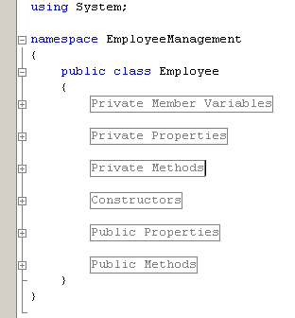
- Compound words should be cased correctly (FxCop Microsoft.Naming CA1702) [3]
Avoid creating compound words from terms which exist in the dictionary as discrete terms. Do not create a compound word such as 'StopWatch' or 'PopUp'. These terms are recognized in the dictionary and should be cased as 'Stopwatch' and 'Popup'.
- Identifiers should differ by more than case. (FxCop Microsoft.Naming CA1708)
Do not use names that require case sensitivity for uniqueness. Components must be fully usable from both case-sensitive and case-insensitive languages. Since case-insensitive languages cannot distinguish between two names within the same context that differ only by case, components must avoid this situation.
- Identifiers should have correct prefix (FxCop Microsoft.Naming CA1715)
Prefix interface names with the letter 'I' to indicate that the type is an interface, as in IFormattable. Prefix generic type parameter names with the letter 'T' and provide them with descriptive names, as in Dictionary<TKey, TValue>, unless a single 'T' is completely self-explanatory, as in Collection<T>. Use Pascal casing for both interface and type parameter names. Use abbreviations sparingly. Do not use the underscore character. Do use similar names when defining a class/interface pair where the class is a standard implementation of the interface. The names should differ only by the letter I prefixed on the interface name, as with Component and IComponent.
- Identifiers should have correct suffix (FxCop Microsoft.Naming CA1710)
Types that extend certain base types have specified name suffixes. Types that extend Attribute, for example, should be suffixed in 'Attribute', as in ObsoleteAttribute. This rules checks types that extend several base types, including Attribute, Exception, EventArgs, IMembershipPermission, Stream, and others.
- Identifiers should not match keywords (FxCop Microsoft.Naming CA1716)
Identifiers which conflict with reserved language keywords should be avoided. Using a reserved keyword as an identifier makes it harder for consumers in other languages to use your API.
- Parameter names should not match member names (FxCop Microsoft.Naming CA1719)
Parameter names should be distinct from member names.
public class HelloWorld
{
private int _count;
public HelloWorld(int count)
{
_count = count; //Should not change the parameter name to _count
}
}
- Property names should not match get methods (FxCop Microsoft.Naming CA1721)
A Get method was found with the same name as a property. Get methods and properties should have names that clearly distinguish their function. See the design guidelines for information regarding choosing properties over methods.
- Type names should not match namespaces (FxCop Microsoft.Naming CA1724)
Identifiers which conflict in whole or in part with namespace names should be avoided. Names that describe the purpose or contents of a type are preferred.

Coding styles
- Avoid writing very long methods. A method should typically have 1~50 lines of code. If a method has more than 50 lines of code, you must consider re factoring into separate methods.
- Do not hardcode configuration data. Configuration data should be put into configuration file or database.
- Avoid using member variables. Declare local variables wherever necessary and pass it to other methods instead of sharing a member variable between methods. When sharing a member variable between methods, it will be difficult to track which method changed the value and when.
- Do not make the member variables public or protected. Keep them private and expose public/protected Properties.
- Do not have more than one class in a single file.
- Avoid public methods and properties, unless they really need to be accessed from outside the class. Use “internal” if they are accessed only within the same assembly.
- Declare variables as close as possible to where it is first used. Use one variable declaration per line.
- Use StringBuilder class instead of String when manipulating string objects in a loop. The String object works in weird way in .NET. Each time a string is appended, it is actually discarding the old string object and recreating a new object, which is a relatively expensive operations.
- Never do a 'catch exception and do nothing'. If hiding an exception, there is no way to notice the exception happened or not. Lot of developers uses this handy method to ignore non significant errors. Best practices are to avoid exceptions by checking all the error conditions programmatically. In any case, catching an exception and doing nothing is not allowed. In the worst case, exceptions should be logged for later investigation and system should not be halted.
- When you re throw an exception, use the throw statement without specifying the original exception. This way, the original call stack is preserved.
- Write your own custom exception classes if required in your application. Do not derive your custom exceptions from the base class SystemException. Instead, inherit from ApplicationException.
- A class should be declared as sealed if there is no further inheritance.
- Abstract types should not have constructors (FxCop Microsoft.Design CA1012). Public constructors for abstract types do not make sense because you cannot create instances of abstract types.
- Avoid empty interfaces (FxCop Microsoft.Design CA1040). Interfaces are meant to contain members that specify a set of behaviors. To mark or label a class, use an attribute instead of an empty interface.
- Avoid excessive parameters on generic types (FxCop Microsoft.Design CA1005). Avoid generic types with more than two type parameters as users have difficulties understanding what type parameters represent in types with long type parameter lists.
- Avoid out parameters (FxCop Microsoft.Design CA1021). Using out parameters might indicate a design flaw. Although there are legitimate times to use out parameters, their use frequently indicates a design that does not conform to the design guidelines for managed code.
- Declare types in namespaces (FxCop Microsoft.Design CA1050). A type should be defined inside a namespace to avoid duplication.
- Do not declare static members on generic types (FxCop Microsoft.Design CA1000). The syntax for calling static members on generic types is complex as the type parameter has to be specified for each call.
- Do not declare protected members in sealed types (FxCop Microsoft.Design CA1047). Sealed types cannot be extended, and protected members are only useful if you can extend the declaring type. Sealed types should not declare protected members.
- Do not declare virtual members in sealed types (FxCop Microsoft.Design CA1048). Sealed types cannot be extended, and virtual members are only useful if you can extend the declaring type.
- Do not expose generic lists (FxCop Microsoft.Design CA1002). Do not expose List<T> in object models. Use Collection<T>, ReadOnlyCollection<T> or KeyedCollection<K,V> instead. List<T> is meant to be used from implementation, not in object model API. List<T> is optimized for performance at the cost of long term versioning. For example, if you return List<T> to the client code, you will not ever be able to receive notifications when client code modifies the collection.
- Do not hide base class methods (FxCop Microsoft.Design CA1061). Defining a method in a derived class with the same name and parameters that are more weakly typed as one that is defined in the base class will obstruct access to the method defined in the base class.
- Do not overload operator equals on reference types (FxCop Microsoft.Design CA1046). Most reference types, including those that override System.Object.Equals, do not override the equality operator (==). Most languages provide a default implementation of this operator.
- Do not pass types by reference (FxCop Microsoft.Design CA1045). Although there are legitimate times to use reference parameters, such use frequently indicates a design that does not conform to the design guidelines for managed code.
- Enumerators should be strongly typed (FxCop Microsoft.Design CA1038). Types that implement IEnumerator should also provide a version of the Current property that returns a type other than Object. Implement the interface member explicitly and make the strongly typed version public.
- Exceptions should be public(FxCop Microsoft.Design CA1064). Exception classes should either be public, or have a non-generic public ancestor.
- Implement standard exception constructors (FxCop Microsoft.Design CA1032). Multiple constructors are required to correctly implement a custom exception. Missing constructors can make your exception unusable in certain scenarios. For example, the serialization constructor is required for handling exceptions in XML Web services.
- Lists are strongly typed (FxCop Microsoft.Design CA1039). IList implementations should also provide versions of the IList members that are strongly typed, namely they should specify types other than Object for method and property parameter and return types. Implement the interface members explicitly and make the strongly typed versions public. It is safe to ignore violations of this rule when you are implementing a new object-based collection, such as a linked list, where types based on your collection will determine what the strong type is. These types should expose strongly typed members.
- Override methods on comparable types (FxCop Microsoft.Design CA1036). Types that implement IComparable should redefine Equals and comparison operators to keep the meanings of less than, greater than, and equals consistent throughout the type.
- Replace repetitive arguments with params array (FxCop Microsoft.Design CA1025). Several instances of same-type arguments can be better implemented as a parameter array argument. Generally, if a member declares three or more arguments of the same type, consider using a parameter array.
- Static holder types should be sealed (FxCop Microsoft.Design CA1052). Static holder types do not provide functionality that derived instances can extend. Inheriting from such a type indicates a flawed design.
- Use events where appropriate (FxCop Microsoft.Design CA1030). A method name suggestive of event functionality was encountered.
- Use generic event handler instances (FxCop Microsoft.Design CA1007). Do not declare new delegates to be used as event handlers when targeting a version of the .NET Framework that supports generics. Use an instance EventHandler<T> instead.
- Use properties where appropriate (FxCop Microsoft.Design CA1024). Properties should be used instead of Get/Set methods in most situations. Methods are preferable to properties in the following situations: the operation is a conversion, is expensive or has an observable side-effect; the order of execution is important; calling the member twice in succession creates different results; a member is static but returns a mutable value; or the member returns an array.
- Do not hardcode locale specific strings (FxCop Microsoft.Globalization CA1302). Do not use string literals for system items that have locale-specific designations. Special system locations should be retrieved using provided API such as GetFolderPath. See the System.Environment.SpecialFolder enumeration for more information.
- Set locale for data types (FxCop Microsoft.Globalization CA1306). In most cases, Locale should be explicitly set to CultureInfo.InvariantCulture on DataSet and DataTable instances. Upon creation of a DataSet or DataTable instance, the Locale is set to the current culture. In most cases, the Locale should be set to CultureInfo.InvariantCulture to guarantee proper sorting behavior in all cultures.
- Specify CultureInfo (FxCop Microsoft.Globalization CA1304). If an overload exists that takes a CultureInfo argument, it should always be called in favor of an overload that does not. The CultureInfo type contains culture-specific information required for performing numeric and string operations, such as casing, formatting, and string comparisons. In scenarios where conversion and parsing behavior should never change between cultures, specify CultureInfo.InvariantCulture, otherwise, specify CultureInfo.CurrentCulture.
- Specify IFormatProvider (FxCop Microsoft.Globalization CA1305). If an overload exists that takes an IFormatProvider argument, it should always be called in favour of an overload that does not. Some methods in the runtime convert a value to or from a string representation and take a string parameter that contains one or more characters, called format specifies, which indicate how the value is to be converted. If the meaning of the format specified varies by culture, a formatting object supplies the actual characters used in the string representation. In scenarios where sorting and comparison behavior should never change between cultures, specify CultureInfo.InvariantCulture, otherwise, specify CultureInfo.CurrentCulture.
- Specify StringComparison (FxCop Microsoft.Globalization CA1307). If an overload exists that takes a StringComparison argument, it should always be called in favour of an overload that does not.
- Use ordinal StringComparison (FxCop Microsoft.Globalization CA1309). For non-linguistic comparisons, StringComparison.Ordinal or StringComparison. OrdinalIgnoreCase should be used instead of the linguistically-sensitive StringComparison.InvariantCulture.

Comments
- Comments should be written in order to make code understandable and maintainable.
- Only write comments when necessary, do not write comments for every line of code and every variable declared.
- Use // or /// for comments. Avoid using /* … */
- Do not write comments if the code is easily understandable without comment. The drawback of having lot of comments is that if you change the code and forget to change the comment, it will lead to more confusion.
- Fewer lines of comments will make the code more elegant. But if the code is not clean/readable and there are less comments, that is worse.
- Writes clean, readable code such a way that it doesn't need any comments or very little to understand.
- Perform spelling check on comments and also make sure proper grammar and punctuation is used.

References
[1] About RUP, Iterrative Model:
http://www.answers.com/topic/iterative-and-incremental-development
[2] .NET Naming Guidelines:
http://msdn.microsoft.com/en-us/library/ms229002.aspx
[3] FxCop rules and Code Analysis for Managed Code Warnings
http://msdn.microsoft.com/en-us/library/ee1hzekz.aspx

